**Program no____11_____**

**Program Title______Servo motor_______**

**Aim Rotates clockwise and anticlockwise**

**Hardware Required**

* Arduino Board
* Remote
* Servo Motor
* IR sensor

**Circuit Diagram**

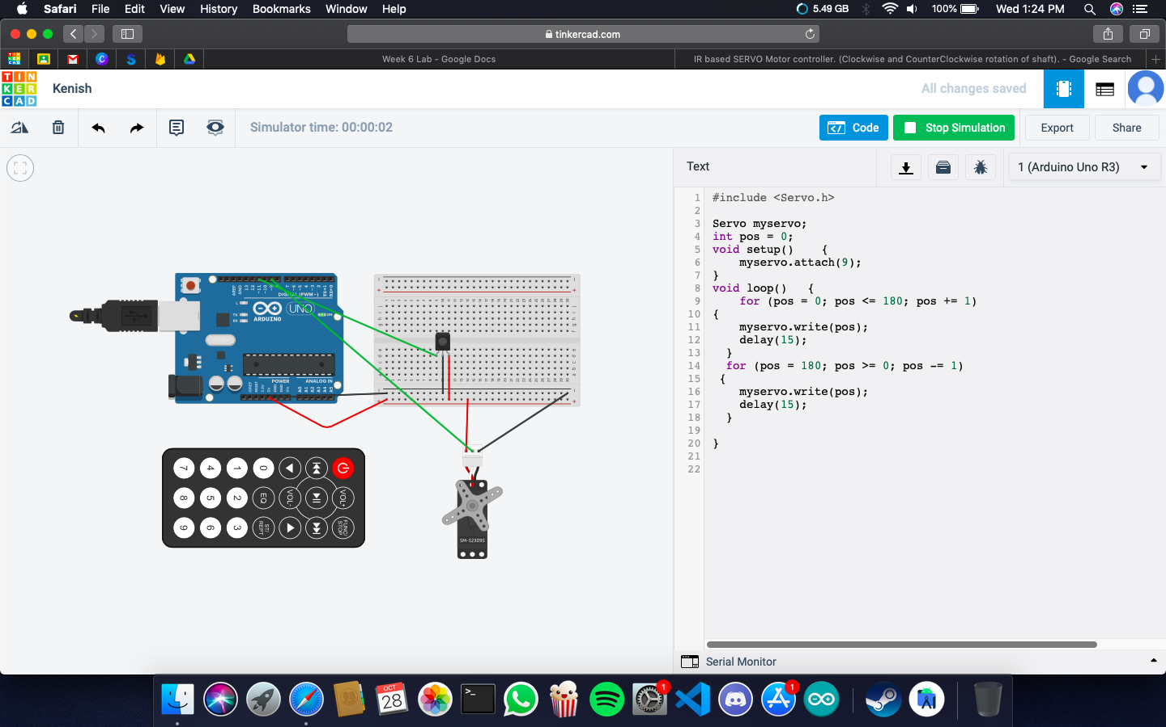

**Code:**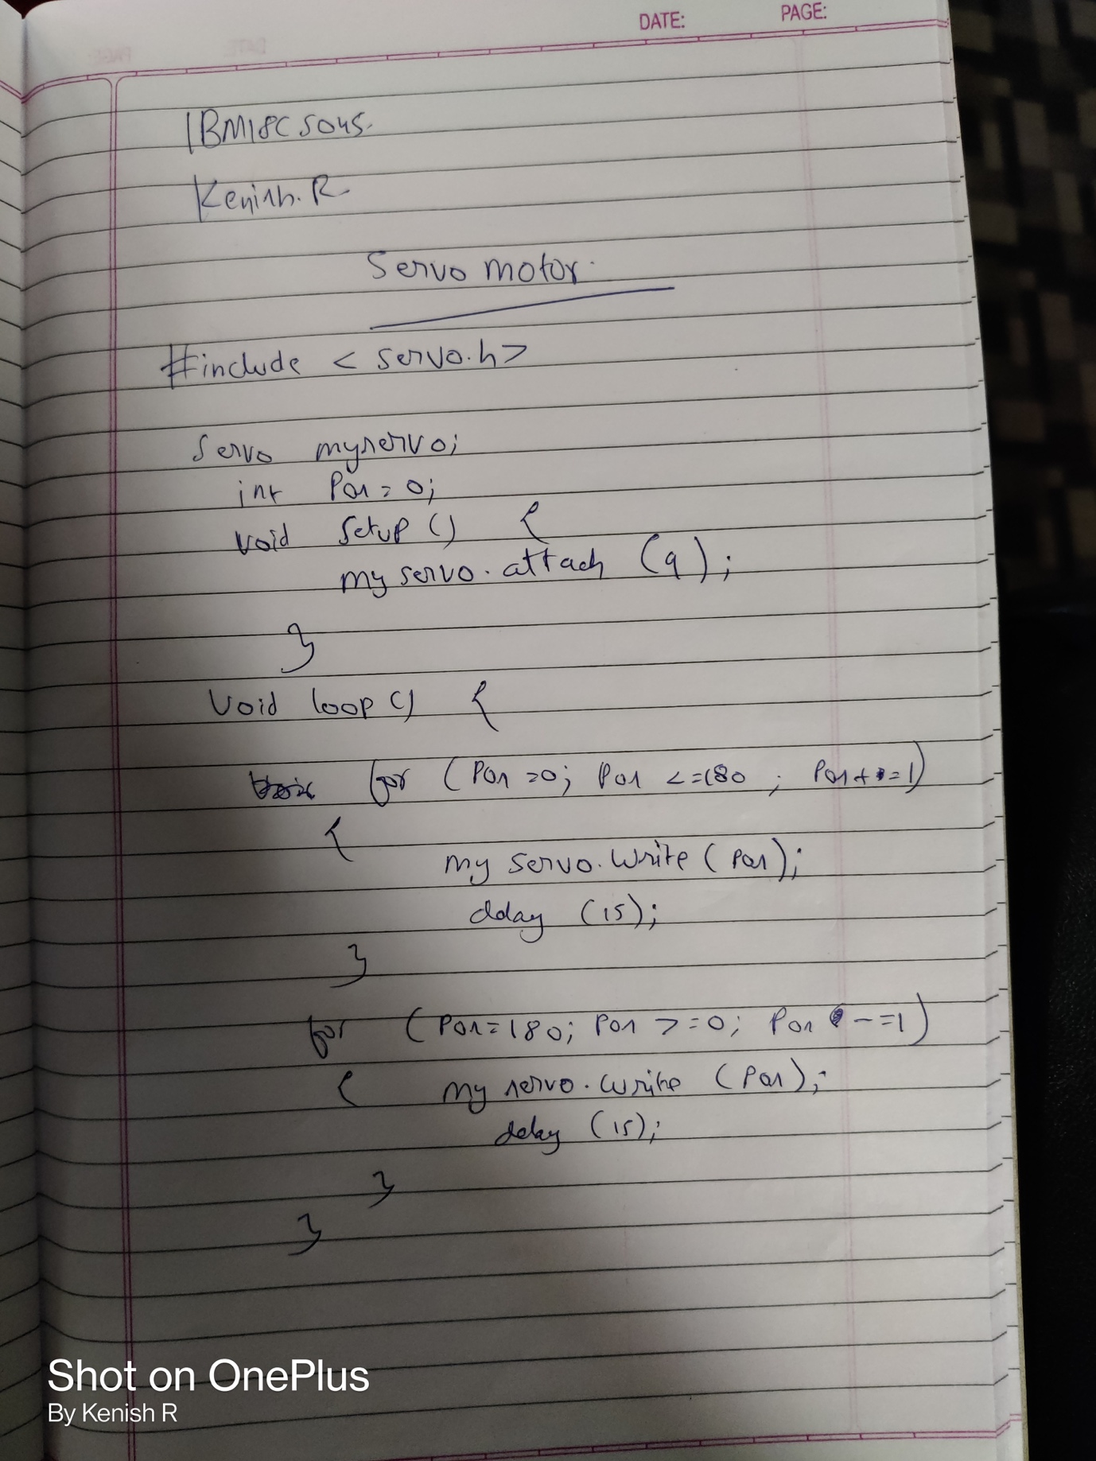

**Observation /Output**

**Rotates clockwise and anticlockwise**